Co2

2.1
Aim:
To generate and distinguish between periodic and aperiodic signals using MATLAB. The
Aim is to demonstrate the fundamental difference between periodic and aperiodic signals by
creating examples of each and analyzing their properties.
Program
clc;
clear;
close all;
% Time axis
t = -5:0.01:5;
% Periodic Signal (Sine Wave)
x1 = sin(2*pi*t);
% Aperiodic Signal (Exponential Decay)
x2 = exp(-abs(t));
% Plotting
figure;
subplot(2,1,1);
plot(t,x1,'LineWidth',2);
grid on;
title('Periodic Signal');
xlabel('Time (s)');
ylabel('Amplitude');
subplot(2,1,2);
plot(t,x2,'LineWidth',2);
grid on;
title('Aperiodic Signal');
xlabel('Time (s)');
ylabel('Amplitude');
output wave form
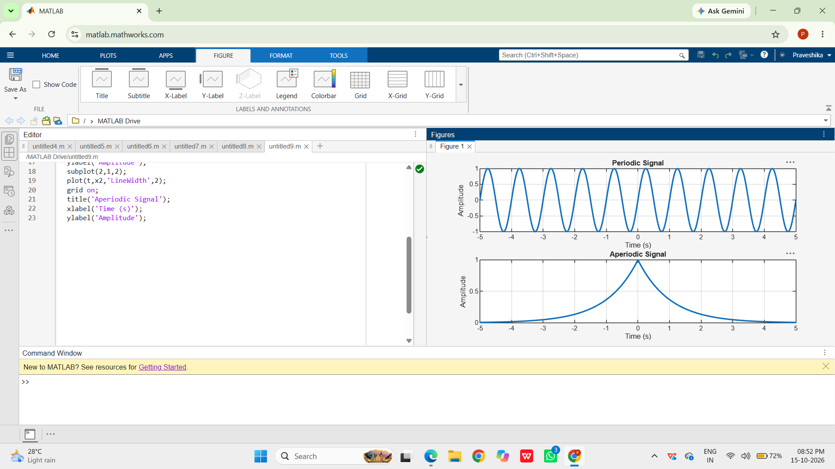
Result:
• Periodic Signal: The sinusoidal signal repeats itself at regular intervals, making it
periodic.
• Aperiodic Signal: The exponentially decaying signal does not repeat, showcasing
that it is aperiodic.
2.2
Aim
Decompose a signal into even and odd parts and verify reconstruction.
Program
clc;
clear;
close all;
% Time axis
t = -5:0.1:5;
% Original Signal
x = t.^3 + t;
% Time-reversed Signal
x_rev = (-t).^3 + (-t);
% Even Component
xe = (x + x_rev)/2;
% Odd Component
xo = (x - x_rev)/2;
% Reconstruction of Original Signal
x_reconstructed = xe + xo;
% Plotting
figure;
subplot(4,1,1);
plot(t,x,'LineWidth',2);
grid on;
title('Original Signal x(t)');
xlabel('Time');
ylabel('Amplitude');
subplot(4,1,2);
plot(t,xe,'LineWidth',2);
grid on;
title('Even Component x_e(t)');
xlabel('Time');
ylabel('Amplitude');
subplot(4,1,3);
plot(t,xo,'LineWidth',2);
grid on;
title('Odd Component x_o(t)');
xlabel('Time');
ylabel('Amplitude');

subplot(4,1,4);
plot(t,x_reconstructed,'LineWidth',2);
grid on;
title('Reconstructed Signal x_e(t) + x_o(t)');
xlabel('Time');
ylabel('Amplitude');
output waveform
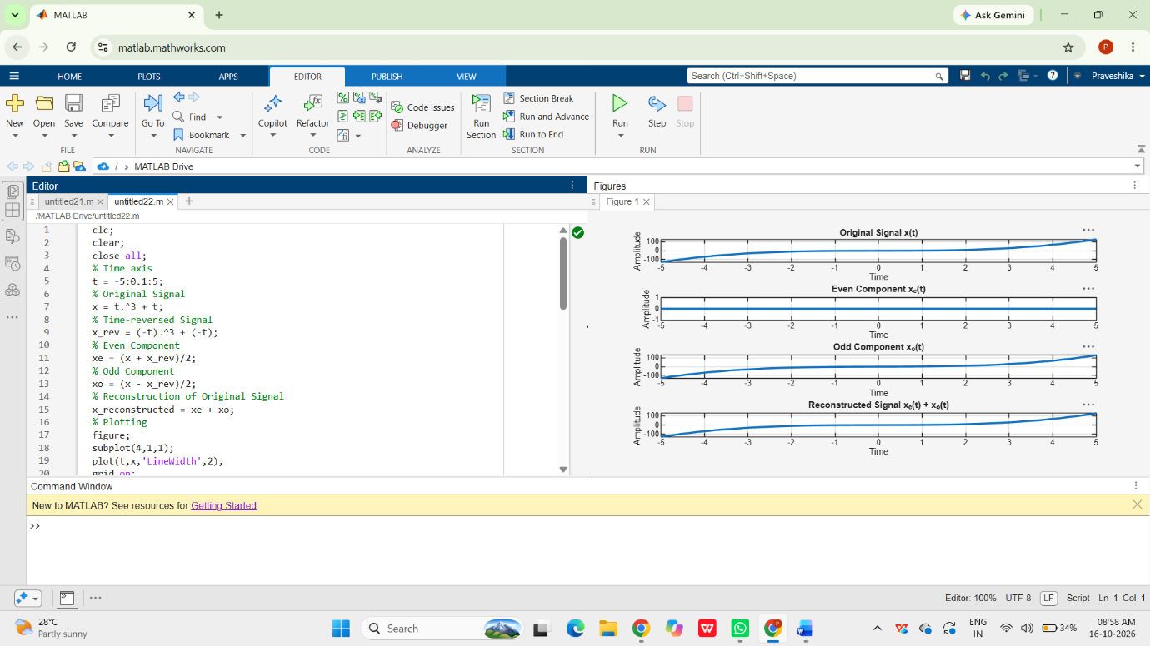
Result
Signal equals sum of even and odd parts.

2.3
Aim
Demonstrate amplitude and time scaling.
Program
clc;
clear;
close all;
% Time axis
t = -5:0.01:5;
% Original Signal
x = sin(2*pi*t);
% Amplitude Scaling
x_amp = 2*x;
% Time Scaling (Compression)
x_time = sin(2*pi*2*t);
% Plotting
figure;
subplot(3,1,1);
plot(t,x,'LineWidth',2);
grid on;
title('Original Signal x(t)');
xlabel('Time (s)');
ylabel('Amplitude');
subplot(3,1,2);
plot(t,x_amp,'LineWidth',2);
grid on;
title('Amplitude Scaled Signal 2x(t)');
xlabel('Time (s)');
ylabel('Amplitude');
subplot(3,1,3);
plot(t,x_time,'LineWidth',2);
grid on;
title('Time Scaled Signal x(2t)');

xlabel('Time (s)');
ylabel('Amplitude');
outputwaveform
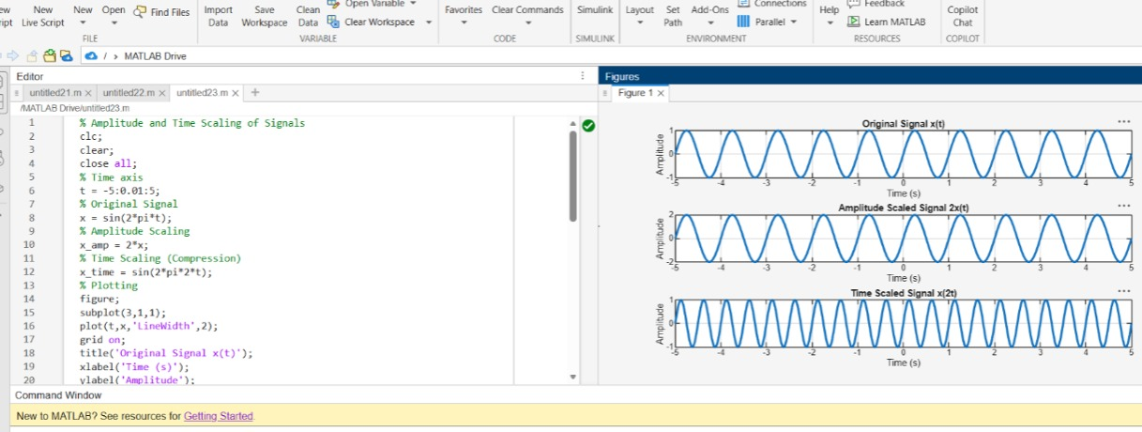

Result
Scaling affects amplitude or time axis accordingly.
2.4
Aim
Demonstrate time shift and reversal.
Program
clc;
clear;
close all;
% Time axis
t = -5:0.01:5;
% Original Signal
x = sin(2*pi*t);
% Time Shift (Delay by 2 seconds)
x_shift = sin(2*pi*(t-2));
% Time Reversal
x_reverse = sin(2*pi*(-t));
% Plotting
figure;
subplot(3,1,1);
plot(t,x,'LineWidth',2);
grid on;
title('Original Signal x(t)');
xlabel('Time (s)');
ylabel('Amplitude');
subplot(3,1,2);
plot(t,x_shift,'LineWidth',2);
grid on;
title('Time Shifted Signal x(t-2)');
xlabel('Time (s)');
ylabel('Amplitude');
subplot(3,1,3);
plot(t,x_reverse,'LineWidth',2);
grid on;
title('Time Reversed Signal x(-t)');
xlabel('Time (s)');
ylabel('Amplitude');
output waveform
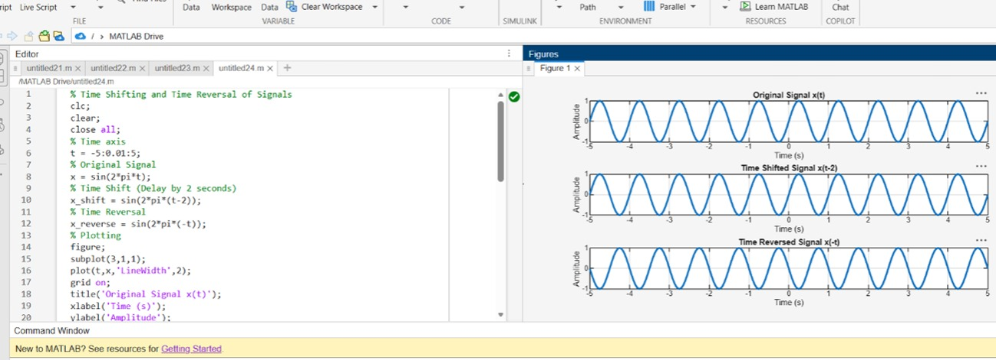
Result
The sinusoidal signal was successfully subjected to time shifting and time reversal using
MATLAB. The time-shifted signal was delayed by 2 seconds, while the time-reversed signal
was obtained by reflecting the original signal about the vertical axis, demonstrating
fundamental signal transformation operations.

